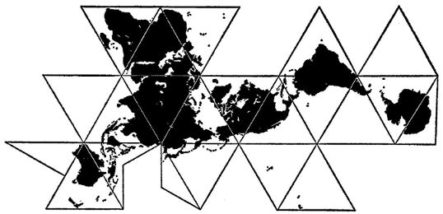
World History II
Mr. Daniel Kosogof
Room 147
Email: daniel.kosogof@bvcps
Website:
https://mrkosogof.weebly.com/
Remind code:________________

“Somewhere, something incredible is waiting to be known.” – Carl Sagan

This course will analyze human history as it rose from the renaissance till modern times. We will…
Think critically about the decisions and events that shaped the world and what factors influenced them.
Work in a technologically integrated classroom to fully immerse ourselves in the material and go on an adventure.
Interpret data and charts to gather information about a time period or society.
Use information generated from primary sources and secondary sources to develop a greater understanding of history.
Analyze primary sources to understand its nature and purpose.
Compare multiple perspectives on historical events while considering economic, political and social influences
There is a story and history behind everything, search out the why and the world opens up.
General Class Rules:
Be respectful, treat others how you would like to be treated.
Bathrooms:
No student will be allowed to leave class the first or last 10 minutes of the class. If you need to use the restroom, ask at an appropriate time.
Cellphones:
We will discuss this together to determine a practice that is mutually beneficial.
Conversation:
We will do a large amount of group work, as well as activities in class where you will need to communicate with your classmates. With that in mind when we do individual work you will need to be quiet and respectful allowing others to work in peace.
Swearing:
Cursing and foul language will not be permitted in this school or this classroom.
Note Taking:
We all think we can remember everything but that is not the way it works. In reality we forget about 40% of new information. Good note taking can eliminate that almost completely. I have attached an article about this which gives tips and advice. To add an extra incentive I will periodically do a notebook check to see your notes and make sure you are completing them.
Late Work:
Assignments from the first half of the quarter turned in late will be accepted at a reduction up until the halfway point of the quarter. Assignments from the second half have until the end of the quarter to be turned in and will also receive a reduction.
Blues Academy:
If you ever have a question on the material, need extra help, or need to talk about anything, my door is always open. We want you to succeed.
Attendance Policy:
If you receive 3 unexcused tardies the administration will be contacted.
If you have 3 absences from school administration will step in.
This is your education to create a better future and we are here for you, but we cannot help you if you’re not here.
I, (print name)______________________________________have read this and accept to approach my education with purpose.
Signature:_______________________________________________________________
Parent’s Signature:________________________________________________________
Parent’s Email:___________________________________________________________
Parent’s Phone:__________________________________________________________
Preferred method of contact (circle one)
Email Text Phone Call

