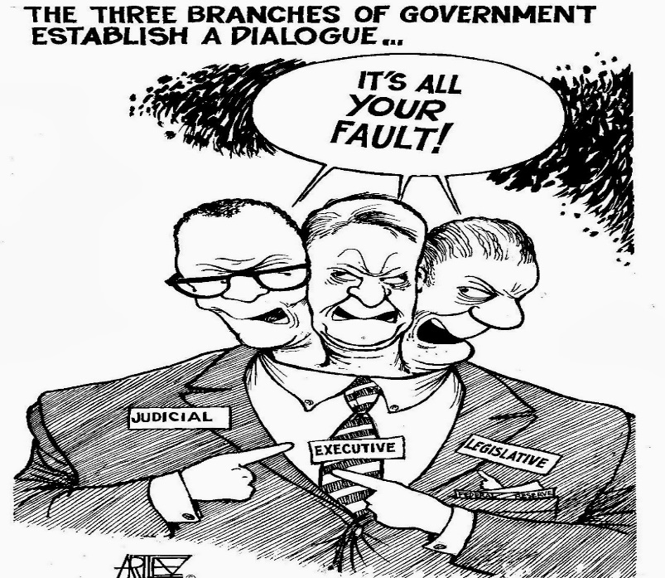
U.S. & VA Government
Mr. Daniel Kosogof
Room 147
Email: daniel.kosogof@bvcps
Website:
https://mrkosogof.weebly.com/
Remind code:________________

“Somewhere, something incredible is waiting to be known.” – Carl Sagan

In this class we will examine multiple types of government, the benefits of our government and its history. We will delve into how the branches of the government interact with each other and ourselves and how we interact with them. Using primary and secondary sources we will construct an understanding of the factors that shape governments around the world. This class will be interactive and you will be an integral part because we will frequently have discussions, debates, and simulations. By the end of the year you will be able to analyze the economic, social, and political factors influencing policy decisions and compare them to previous points in history. Furthermore you will be able to create well developed arguments to state and defend a positon of your choosing.

General Class Rules:
Be respectful, treat others how you would like to be treated.
Bathrooms:
No student will be allowed to leave class the first or last 10 minutes of the class. If you need to use the restroom, ask at an appropriate time.
Cellphones:
We will discuss this together to determine a practice that is mutually beneficial.
Conversation:
We will do a large amount of group work, as well as activities in class where you will need to communicate with your classmates. With that in mind when we do individual work you will need to be quiet and respectful allowing others to work in peace.
Swearing:
Cursing and foul language will not be permitted in this school or this classroom.
Note Taking:
We all think we can remember everything but that is not the way it works. In reality we forget about 40% of new information. Good note taking can eliminate that almost completely. I have attached an article about this which gives tips and advice. To add an extra incentive I will periodically do a notebook check to see your notes and make sure you are completing them.
Late Work:
Assignments from the first half of the quarter turned in late will be accepted at a reduction up until the halfway point of the quarter. Assignments from the second half have until the end of the quarter to be turned in and will also receive a reduction.
Blues Academy:
If you ever have a question on the material, need extra help, or need to talk about anything, my door is always open. We want you to succeed.
Attendance Policy:
If you receive 3 unexcused tardies the administration will be contacted.
If you have 3 absences from school administration will step in.
This is your education to create a better future and we are here for you, but we cannot help you if you’re not here.
I, (print name)______________________________________have read this and accept to approach my education with purpose.
Signature:_______________________________________________________________
Parent’s Signature:________________________________________________________
Parent’s Email:___________________________________________________________
Parent’s Phone:__________________________________________________________
Preferred method of contact (circle one)
Email Text Phone Call

